Due Date: _____________ Name: __________________

Block: _________

**Webquest Task Sheet**

***A Long Walk to Water***

**Introduction:**

Before we read *A Long Walk to Water*, it is helpful to learn about the author, the book, and most importantly the true story that inspired this novel. This webquest will help you imagine what life was like for the young boy and girl who had to survive a civil war, deal with the lack of food and water, and cope with the constant fear of losing their family and friends. As you go through the various weblinks, think about how you would feel. How would you survive? Would you continue to push on and fight for survival?

Complete the questions on this task sheet with the information you find on the links. Navigating through these websites will help build your background knowledge and prepare you for reading *A Long Walk to Water.*

**Getting to Know the Book and Author:**

1. Circle which word best describes the land shown in the book talk? _barren_   _lush_  _crowded_
2. The book talk presenter tries to grab your attention by sharing that in the novel after gun shots are fired, the teacher tells Salva to: __________________________, _____________________, and don’t go _________.
3. The author, ______________________, received a Newbery Medal in 2002 for this novel: ______________________.

(name)

1. According to the author, the novel *A Long Walk to Water* is based on the true story of Salva who is one of __________________ Sudanese “___________________________”.

**Gaining an Understanding of Setting and Theme:**

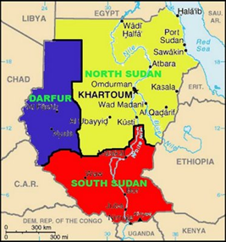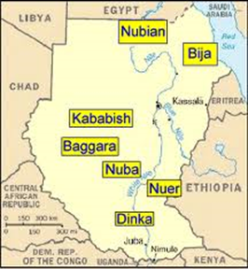

1. During what years did the 2nd civil war take place? ___________ to __________
2. Who was most affected by the war? ___________________________________________
3. How many died during the civil war? ______________________
4. What is wrong with the water that the Sudanese people travel all day to get? ______________

     ____________________________________________________________________________________

1. What organization did Salva create that has helped the Sudanese people. Hint: The non-profit organization has built over 177 water wells in South Sudan? ___________________________________
2. What continent is South Sudan on? _______________________
3. What river is essential for the people and animals of South Sudan? ____________________
4. When did Sudan split into two countries? ________________
5. According to the last paragraph, Sudan has large areas of land, as well as what other two resources? ________________ and ____________________.
6. When did the Peace Agreement signing happen? __________

**Understanding Cultures in *A Long Walk to Water***

1. How many words do the Dinka trive have for cattle? ___________ Explain why do you think is this so: ______________________________________________________________________________________
2. Due to civil war, what five places did the Dinka tribe migrate to? ______________________,

  __________________, ___________________, _____________________, and ____________________.

1. How long have the Dinka been on the move? ______________
2. What is the name of the second tribe? _____________________
3. This tribe is devoted to raising _________________.
4. Where does this tribe spend time during the rainy season? _______________ Where do they spend time in the dry season? _____________________ Why do you think this is so? ________________________________________________________________________________________________________________________________________________________________________________

*Now that you’ve completed the webquest, use the space below to describe how you would feel if you were a young boy or girl who had to survive these hardships year after year. In the space below, explain how you would feel, what you would do to survive, and how you continue to push on and fight for survival.*

________________________________________________________________________________________________________________________________________________________________________________________________________________________________________________________________________________________________________________________________________________________________________________________________________________________________________________________________________________________________________________________________________________________________________________________________________________________________________________________________________________________________________________________________________________________________________________________________________________________